**Raspberry Pi Marine Heatwave Simulator project**

Amelia Ritger



This work is licensed under the [Apache License 2.0](https://github.com/ameliaritger/MHWsim/blob/main/LICENSE).

**Contents**

1. Introduction
2. Materials, Tools, and Consumables
3. Preparing the Raspberry Pi
4. Preparing the Relay HAT
5. Preparing the Perma-Proto HAT
6. Assembling the system
7. Adapting the code to your experiment

**1. Introduction**

Ocean acidification monitoring efforts are a crucial component of tracking the impacts of climate change in marine ecosystems. However, the high instrument cost presents a major barrier to the production of scientific knowledge and has resulted in a highly fragmented understanding of the global progression of acidification. Our project built upon an existing nearshore marine pH sensor design which utilizes a Durafet pH electrode. Our goal was to lower barriers to access by significantly lowering the cost of, and improving approachability to, the design and use of pH sensor electronics. We have created a more compact design using open-source components based on the popular and easy-to-use Arduino platform that eliminates over $900 from the cost of the sensor electronics. We demonstrate with lab and field testing that switching to Arduino-based sensor electronics maintains high data fidelity. Our design supports open science by allowing more individuals and research groups to engage in high-quality oceanographic research.

This document provides guidance on the construction of the data-logger electronics associated with the Durafet-based pH sensor. *This document is a work in progress, please stay tuned for updates!*

**2. Materials, Tools, and Consumables**

|  |  |  |
| --- | --- | --- |
| **ITEM** | **QUANTITY** | **PRICE** |
| **Tools** | | |
| Soldering iron | 1 | varies |
| Wire strippers | 1 | varies |
| Needle nose pliers | 1 | varies |
| Flat head and Phillips head screwdriver | 1 | [$1.50](https://www.adafruit.com/product/3284) |
| Razor blade | 1 | [~$5](https://www.amazon.com/Single-Edge-Razor-Blade-Pack/dp/B08FW6CYG5) |
| **Materials** | | |
| Raspberry Pi 4 (4GB) | 1 | [$55](https://www.digikey.com/en/products/detail/raspberry-pi/SC0194-9/10258781) |
| microSD card (32GB+) | 1 | [~$10](https://www.amazon.com/SanDisk-Ultra-microSDXC-Memory-Adapter/dp/B073JWXGNT/) |
| RPi Relay Board | 1 | ~[$18.99](https://www.amazon.com/gp/product/B07CZL2SKN) |
| Perma-Proto HAT | 1 | [$4.95](https://www.digikey.com/en/products/detail/adafruit-industries-llc/2310/5629417) |
| DS18B20 waterproof thermistor | 1 | [$11.95](https://www.digikey.com/en/products/detail/sparkfun-electronics/SEN-18367/15189222?s=N4IgTCBcDaIIwFYBsAOAtAZQKIDk1xQGYkB2NHAERAF0BfIA) |
| 1/8-1/4W 2.2-4.7k $Ω$ resistor | 1 | [~$0.10](https://www.digikey.com/en/products/detail/lumimax-optoelectronic-technology/CF1-4W2K2JTB/16708111) |
| Extension cord | 1 | [~$6](https://www.homedepot.com/p/10-ft-16-3-SJTW-13-Amp-125-Volt-1625-Watt-Lighted-End-Indoor-Outdoor-Black-Heavy-Duty-Extension-Cord-16310FTBK/314613505) |
| RPi waterproof housing | 1 | varies |
| **Consumables** | | |
| Lead-free solder | 1 | [$6.75](https://www.digikey.com/en/products/detail/nte-electronics-inc/83-7068-1402/12158031) |
| 22 AWG solid core wire | 1 | [$2.95](https://www.digikey.com/en/products/detail/adafruit-industries-llc/290/6226989) |
| Nylon screws | 1 | [$14.95](https://www.digikey.com/en/products/detail/adafruit-industries-llc/3658/8258465) |

**3. Preparing the Raspberry Pi**

Set up your Raspberry Pi (‘RPi’) following the [tutorial](https://projects.raspberrypi.org/en/projects/raspberry-pi-setting-up/0) by the Raspberry Pi Foundation. Once you have communication with your RPi established, you can begin adding more complex features such as remote access and text alert notifications. Otherwise, begin assembling your system.

Note: it is highly recommended that you get your RPi set up on WiFi, unless you plan to use a more permanent, dedicated screen for viewing the desktop environment of your RPi. Read this documentation for setting up your RPi on a wireless network:

<https://www.raspberrypi.com/documentation//computers/configuration.html#the-raspi-config-tool>.

If you are in academia and your campus has an eduroam network, follow this tutorial for getting your RPi connected to eduroam WiFi: <https://inrg.engineering.ucsc.edu/howto-connect-raspberry-to-eduroam/> Note: campus WiFi connections are finnicky, and you very likely will need to contact your campus/department IT services if you are having issues connecting your RPi to campus WiFi.

Once you have a wireless network established, follow this tutorial for setting up VNC remote access on your RPi: <https://magpi.raspberrypi.com/articles/vnc-raspberry-pi>.

If you want to set up text alerts with your RPi (in case of any sensor failures), read through this post: <https://iotdesignpro.com/projects/sending-smtp-email-using-raspberry-pi> and this forum post: <https://forums.raspberrypi.com/viewtopic.php?t=284519>. Note: you will need to create an email address for your RPi in order to do this - you do not want your personal or work email to be at risk for hacking attempts!

**4. Preparing the Relay HAT**

Power to the heaters and chillers is controlled via the relay HAT. To protect the wiring of the heaters and chillers, you will be joining the heaters and chillers to the relay HAT via extension cords. Carefully cut the external sheath of the extension cord with a razor blade to expose the inner wires. Try not to cut through the external wires. Note: If you cut all the way through the wires, you will need to keep them separated with electrical tape (or even better, shrink tubing). There should be three different colored wires – black (power), green (ground), and white (neutral) (Figure FF). Cut the black (power) wire and use wire strippers to expose the stranded wire core. Note: Adding solder to the ends of the wires will keep the strands organized. The Relay HAT I used has three channels (but you can find Relay HATs on Amazon with more or less channels, depending on your needs), each with a screw terminal block. Thread one end of the extension cord black wire to “NOx” and the other into “Cx” on one of the blocks, and secure by tightening with a flat head screwdriver (Figure EE).

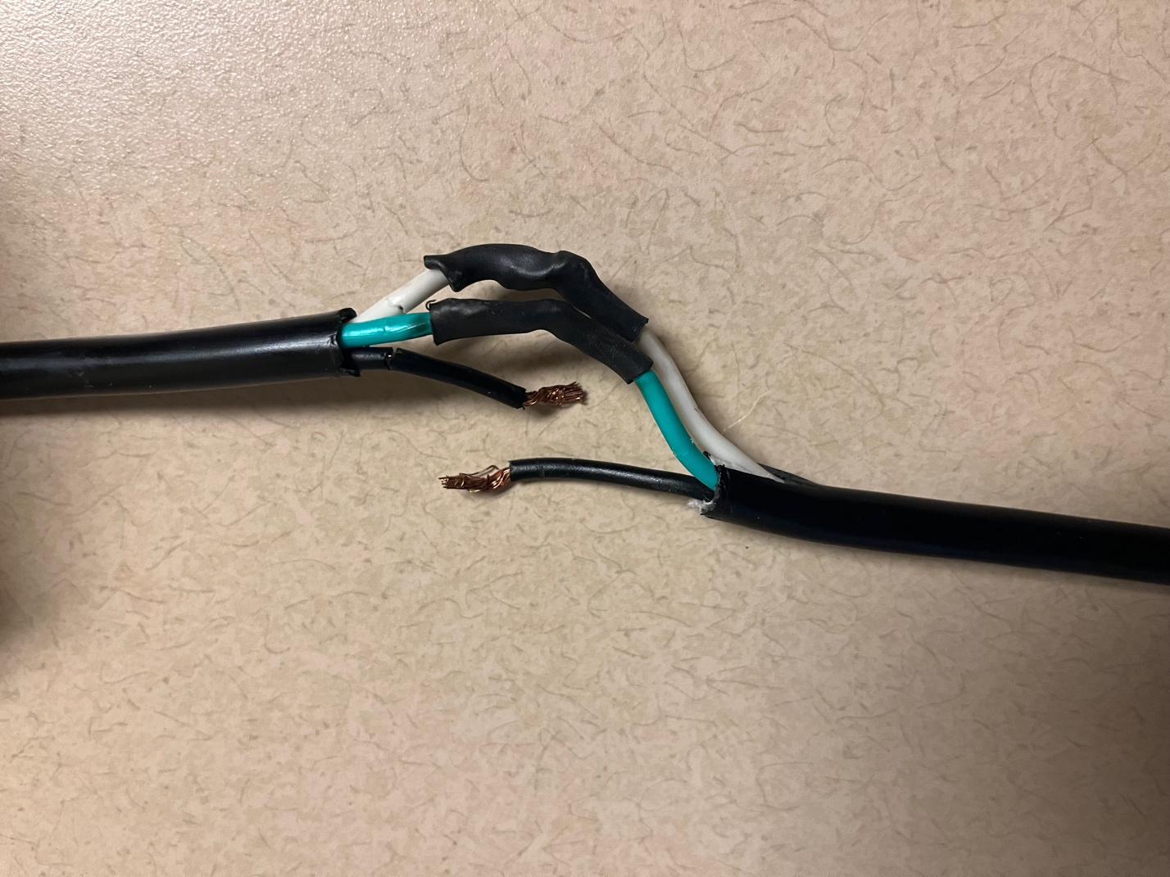

Figure FF. The inner wires of an extension cord. The black wire (power) will be connected through the Relay HAT. Any exposed wire core from the non-power wires is protected with black shrink tubing.

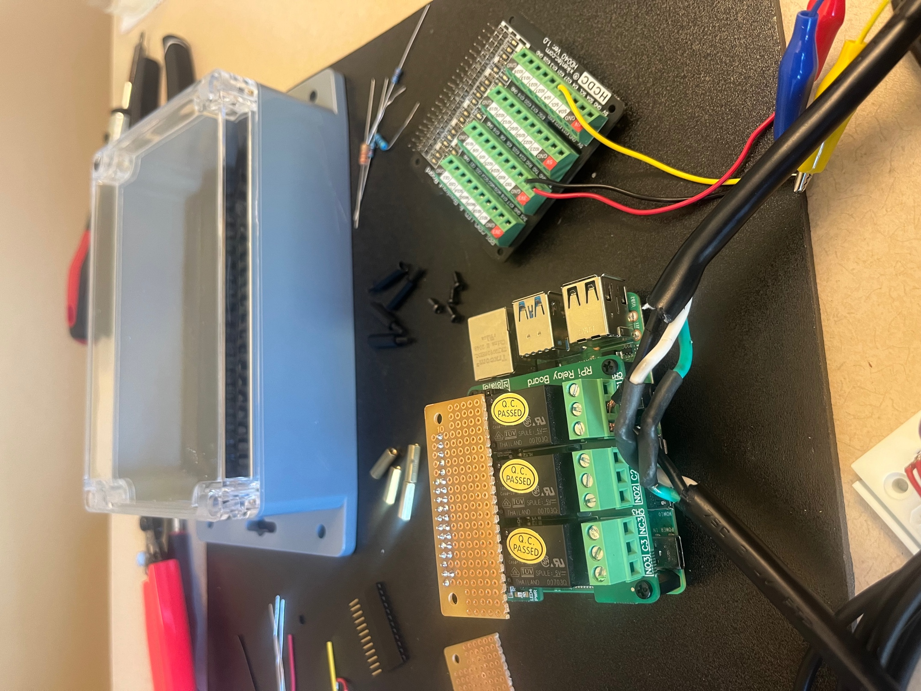

Figure EE. One extension cord plugged into a screw terminal on the Relay HAT.

**5. Preparing the Perma-Proto HAT**

The DS18B20 thermistors are connected to the Raspberry Pi via the Perma-Proto HAT. The thermistors come with three wires VDD (red), GND (black), and GPIO (white/yellow) (Figure AA).

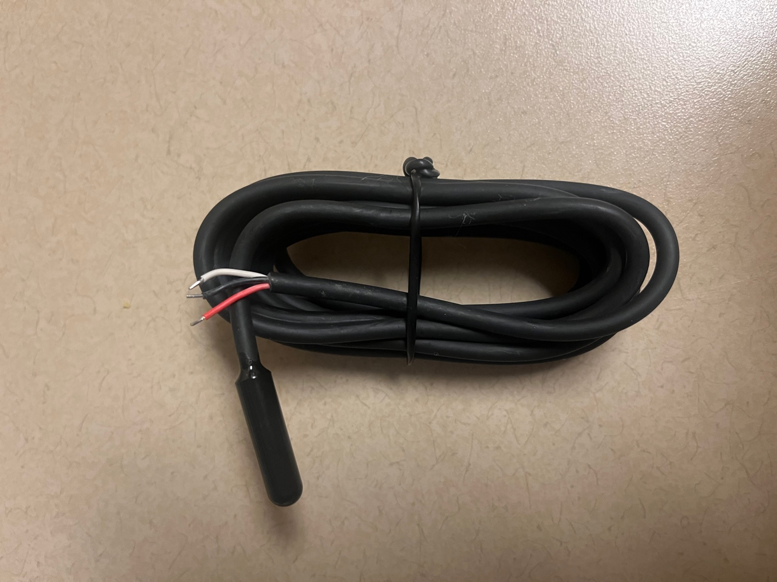

Figure AA. New DS18B20 thermistor with exposed wires, ready to be soldered.

Solder the header to the top row of the HAT, and then solder the various components to the Perma-Proto HAT following the schematic in Figure BB. Strip solid core wire and connect it each of the connections to the RPi headers (blue lines in Figure BB), and for applications with multiple thermistors, use stripped solid core wire to connect like wires across the board (orange lines in Figure BB). Solder a 1/8W 4.7k $Ω$ resistor between the VDD and GPIO lines, as shown in Figure BB. A complete example, with 18 thermistors and a 1/4W 3.2k $Ω$ resistor, is shown in Figure CC. Note: the more thermistors you add to the system, the greater the wattage and lower the resistance value you need for your resistor.

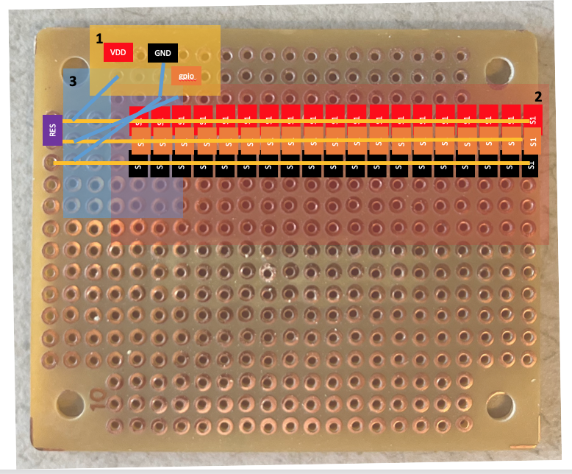

Figure BB. Perma-Proto HAT with locations for thermistor wires (region 2), resistor (region 3), and connections to the RPi header (region 1) to be soldered. It is recommended to solder region 1 first and region 3 last.

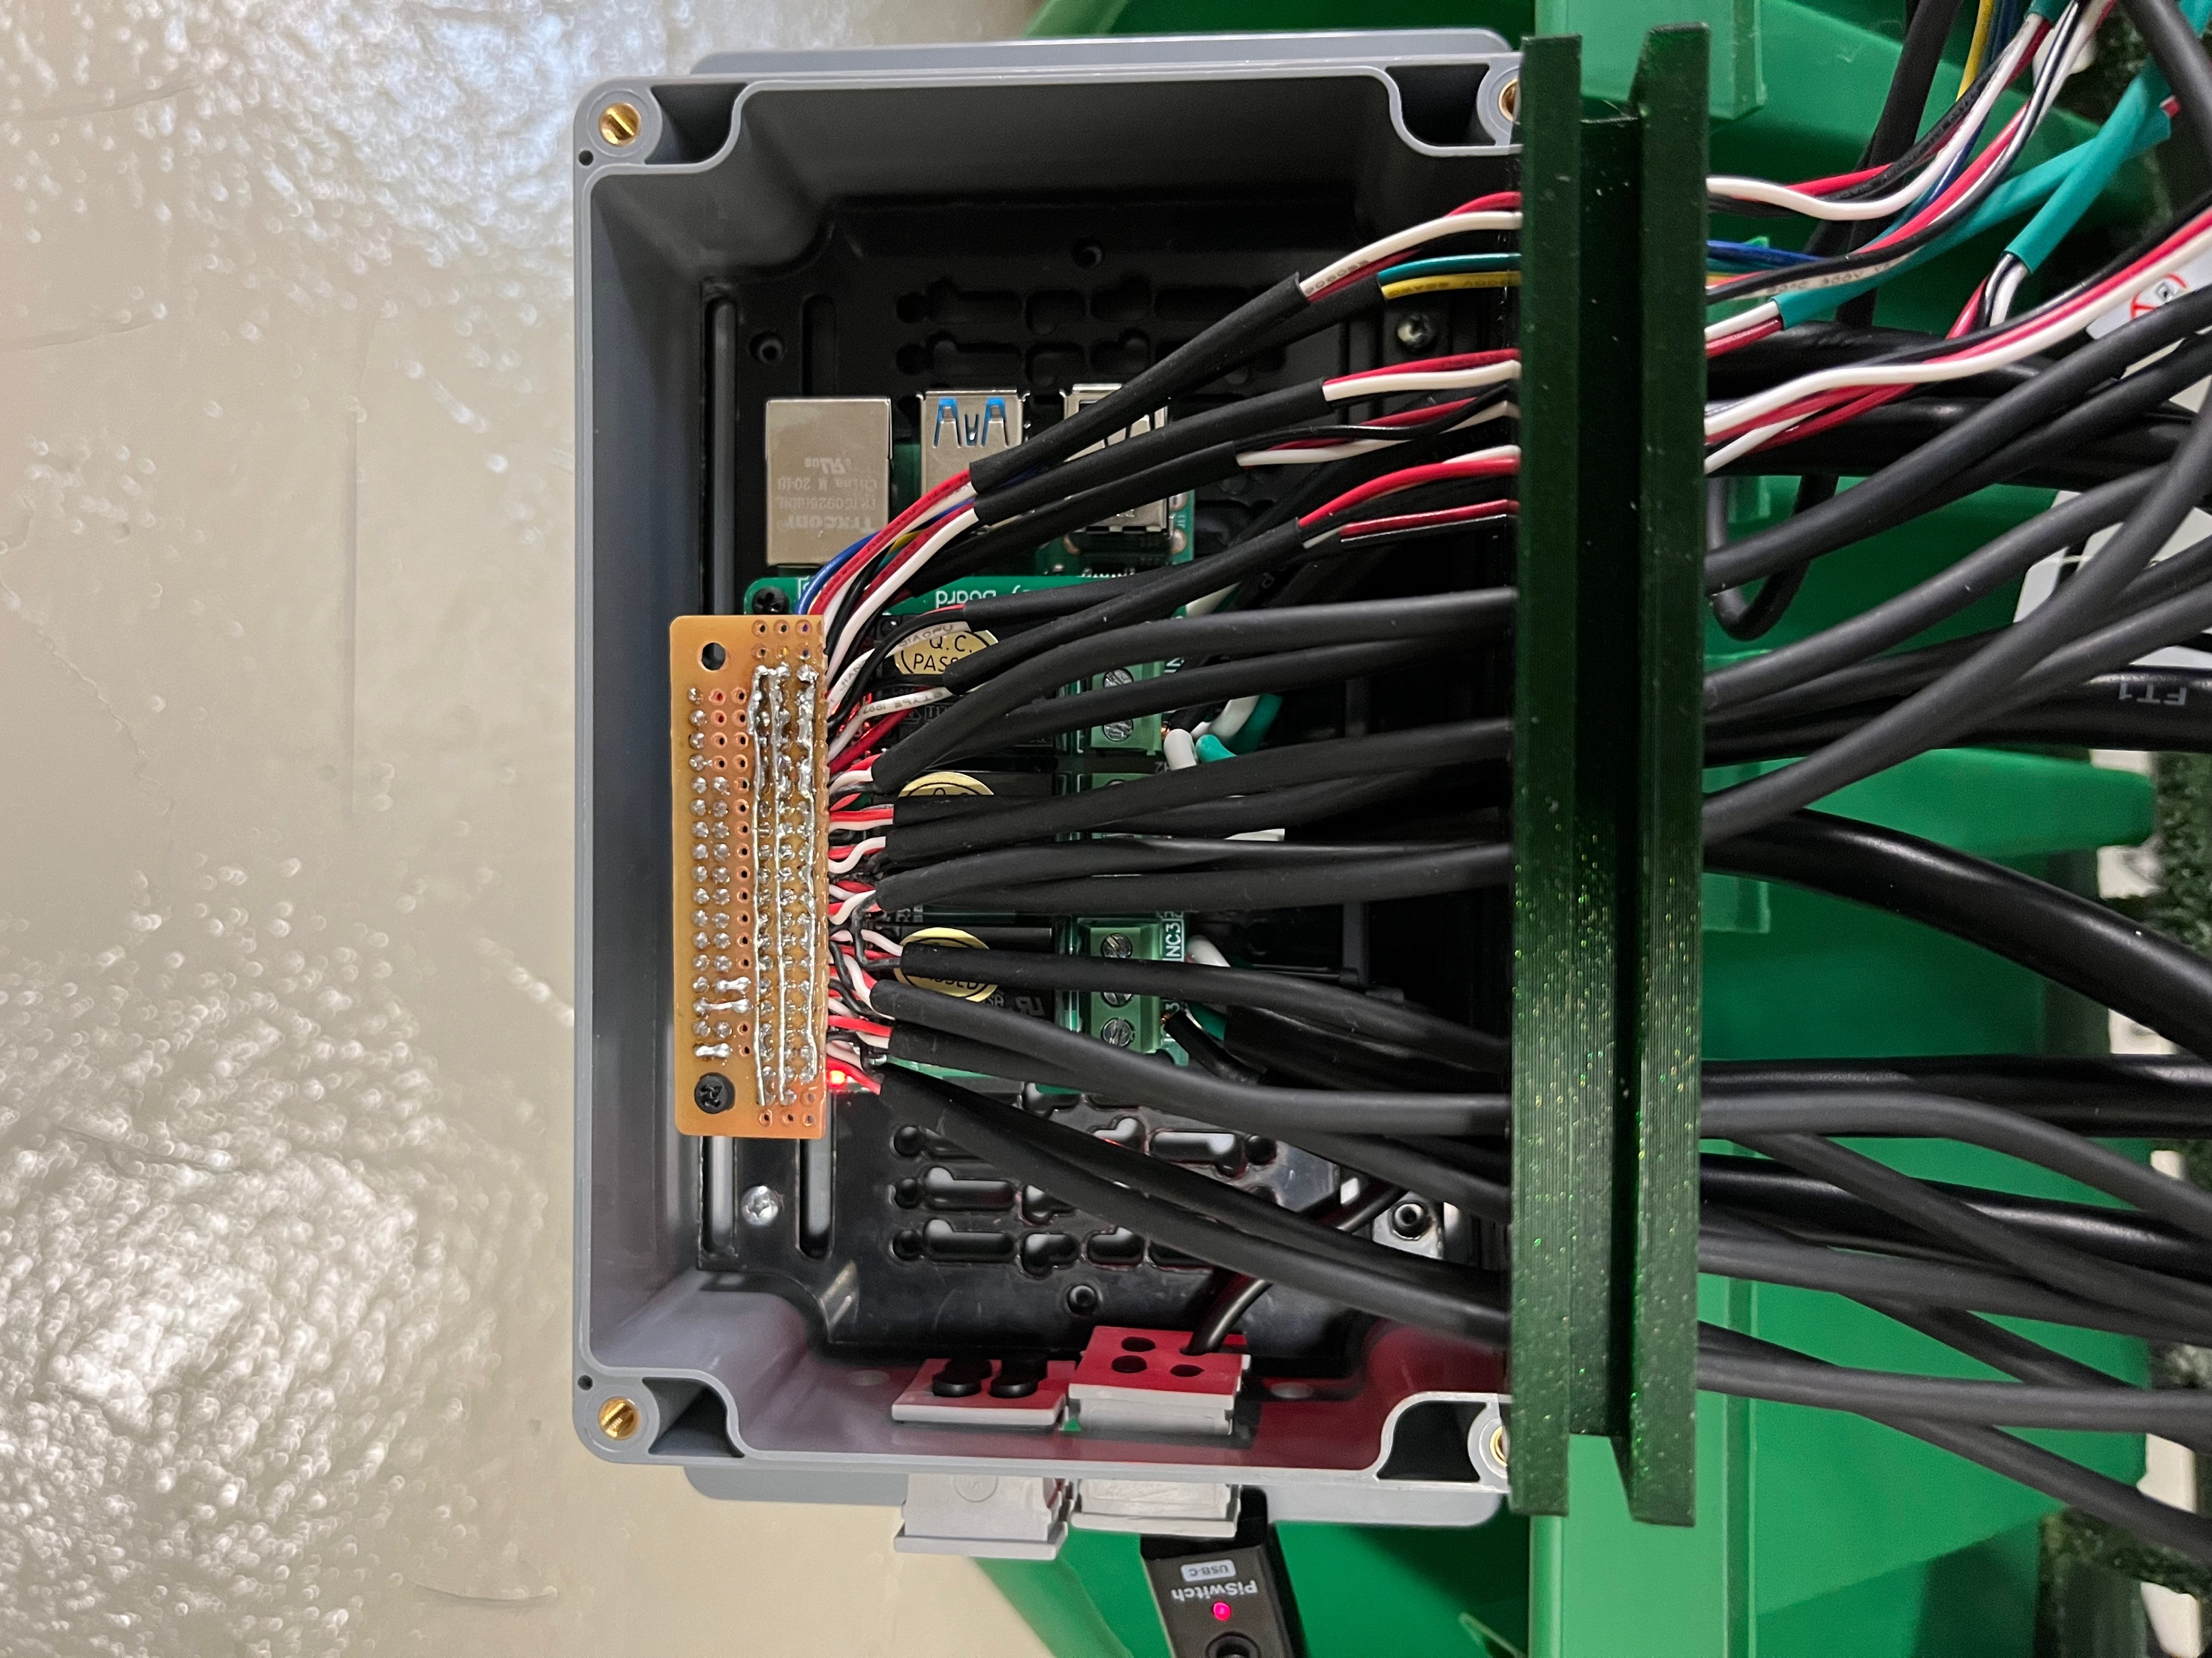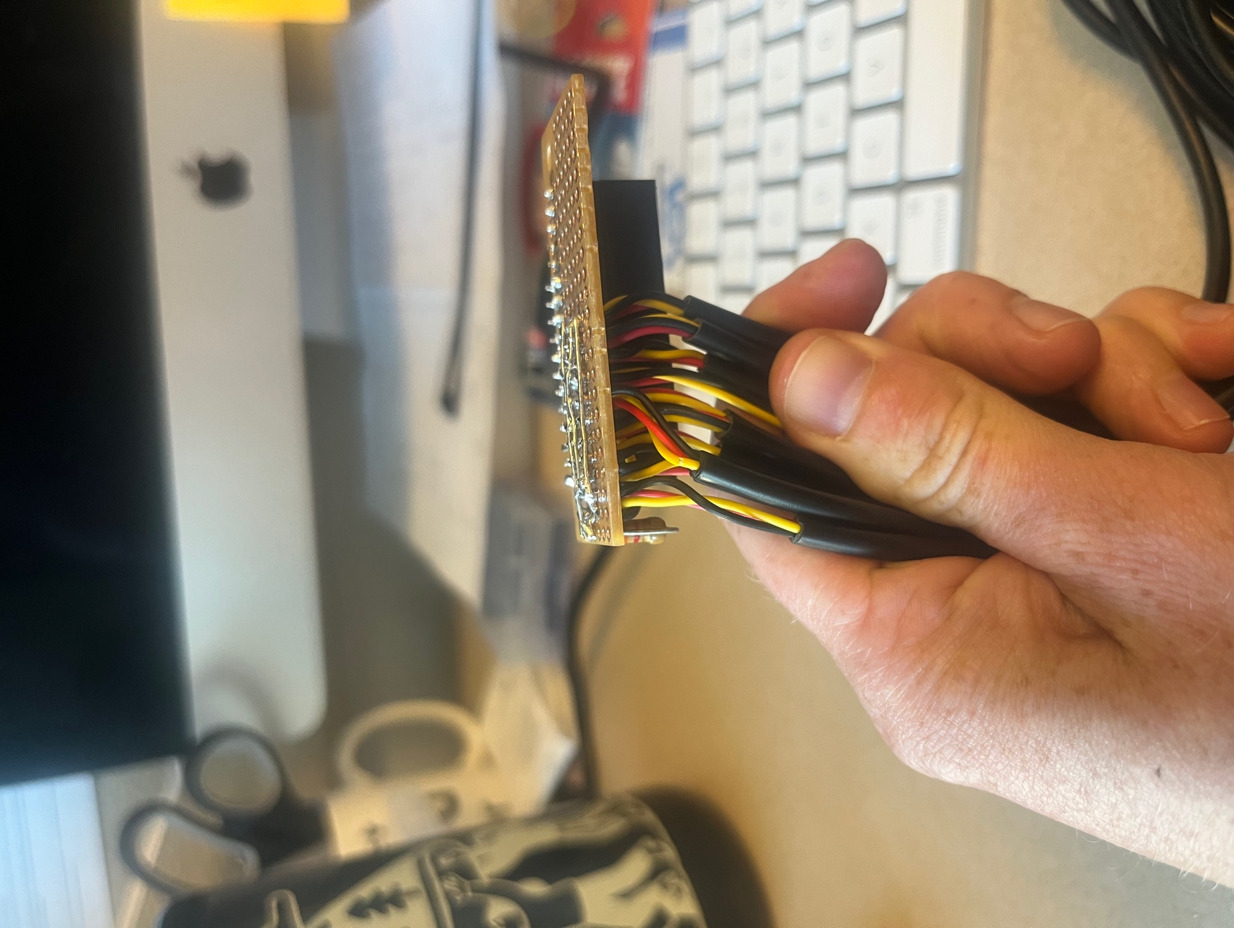

Figure CC. Top and side view of Perma-Proto HAT with all components soldered.

For more information about using DS18B20 temperature sensors with the RPi, read this tutorial: <https://www.circuitbasics.com/raspberry-pi-ds18b20-temperature-sensor-tutorial/>.

If you are still itching for more knowledge, check out these two posts about interfacing multiple DS18B20 sensors with the RPi: <https://www.hackster.io/vinayyn/multiple-ds18b20-temp-sensors-interfacing-with-raspberry-pi-d8a6b0>, and <https://blog.cavelab.dev/2019/10/rpi-ds18b20-temp-sensors/>.

**6. Assembling the system**

Stack the Relay HAT on top of the Rasperry Pi, and then stack the Perma-Proto HAT on top of your Relay HAT (Figure DD). Use nylon screws to carefully secure the three boards to each other. Place this set up inside your favorite waterproof case (example [lower-cost option](https://www.target.com/p/rubbermaid-brilliance-food-storage-container/-/A-53696326) and [higher-cost option](https://sixfab.com/product/raspberry-pi-ip54-outdoor-iot-project-enclosure/)). Now, you are ready to work on the code!

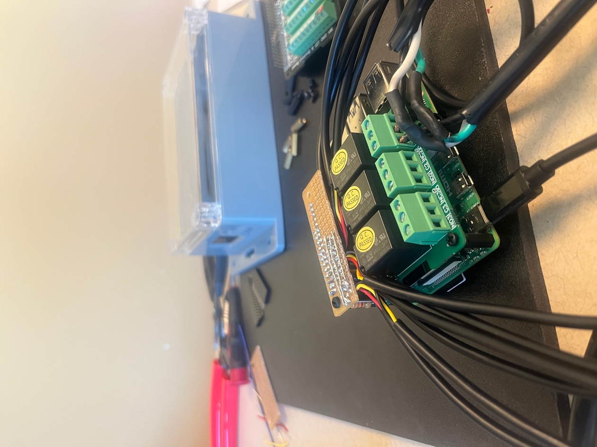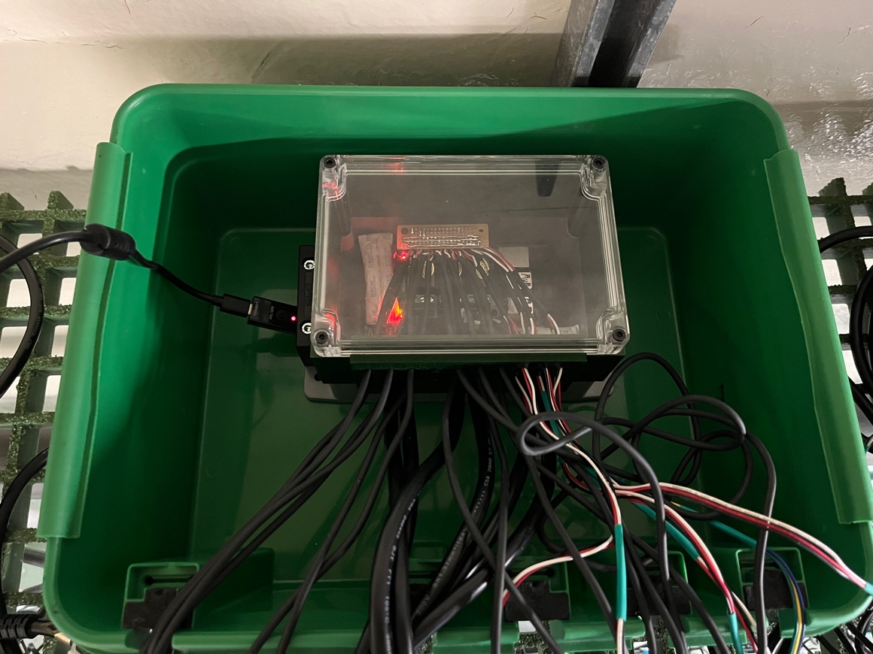

Figure DD. Fully assembled system (left) inside waterproof housing (right).

**7. Adapting the code to your experiment**

The project GitHub repository includes CONFIG.h and SRC.h files alongside a main arduinoCode.ino file, all of which are essential for proper communication and deployment. You should only be editing the CONFIG file for deployment.

To change the file name printed to the SD card, edit the contents within the parentheses on line 4. The filename must be equal or less than 8 characters and must have a .csv file extension. *Default: "filename.csv".*

To change the sampling interval, edit the number within the curly brackets on line 6. This number represents the frequency of sampling in seconds. For example, if you want sampling to occur once every 30 minutes, you will set this number to 1800. *Default: 600.*

To change the deployment start time and date, edit the numbers within the curly brackets on lines 7-9. These numbers represent start date (line 7), and start time in hours (line 8) and minutes (line 9). For example, if you want sampling to occur on the third day of the month at noon, you will set these numbers to 3, 12, 0. Use the numbering intervals recommended in the comments (e.g., 0, not 00, to start sampling at the top of the hour). *Default*: *12, 0, 0.*

To match the RTC time with your computer time, edit the number on line 15. This "fudge factor" represents a number, in seconds, and allows for fine-scale tuning of the timestamp printed to the SD card. Open up the Serial while the Arduino is running to check the difference between timestamp printed on the Serial monitor (left) and the timestamp of the RTC that is printed on the SD card (right of the colon). Alter the fudge factor so that the value of the RTC timestamp aligns with your computer/Serial time, and run the code again to check for alignment. For example, if the Serial timestamp is 5 seconds ahead of the RTC timestamp, then add 5 to the "fudge factor". The fudge factor addresses differences in Arduino code upload times when using different computers - typically, faster processors will have smaller fudge factors (0-10) while slower processors can have fudge factor values higher than 15. *Note*: Uploading code to the Arduino on a new day will often take significantly longer than subsequent uploads, and so it is recommended that you upload at least twice to check your fudge factor is correct. *Default: 15.*

Your Adalogger is now ready for deployment!

**Processing the data ("rCode")**

After deploying your Adalogger, you will be able to collect the .csv data file from the microSD card. These data can then be imported into an R project alongside the R code found on the project GitHub repository for processing. There are four .Rmd files:

* Final_deploy_voltages.Rmd
* Final_OMEGAS.Rmd
* Final_standardize_data.Rmd
* Final_Tris_Cal.Rmd